Do you need to wow your customers? Can you keep up with changing market demand and regulations? Do you have limited resources and too tight schedules? Do you spend days on managing dependencies and fear for years of maintenance? Your answer is

Qt for Device Creation

Trusted by 70+ industries
What if you could get a head start on your project with intuitive libraries and pre-built software components that can be re-used for any software project on any platform? Focus on creating unique user experiences instead of grunt work with development tools that simplify the work of both designers and programmers. That’s why over a million users have chosen Qt – and so should you.
Qt has everything you need to design, develop, test, deploy and maintain your software throughout your product lifecycle. Create high performance embedded systems with 3D/2D user interfaces and deploy and test on your target hardware from day one.
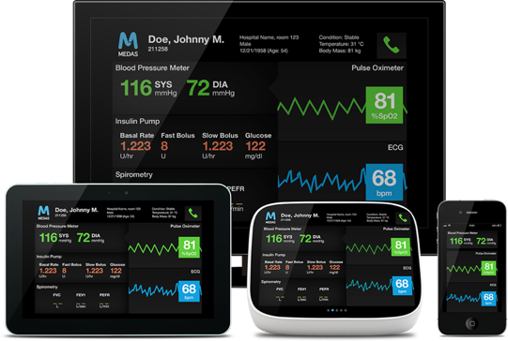

Performance and scalability | Modern user experience | Shorter time to market
Optimize your performance and utilize your hardware resources efficiently with C++, QML or HTML5. You can scale up to target high end multiscreen systems as well as scale down to target small devices with very limited resources. | Speed up the creation of beautiful 3D/2D AR/VR or touch based UIs that scale to a variety of screen sizes. Ready-made UI libraries with drag and drop design functionality. | Reduce development cost & time with intuitive APIs, ready-made software stacks & solutions with full support for a wide range of off-the-shelf hardware and operating  systems.

Power of Cross-Platform Qt
Cross platform support in Qt means freedom of choosing between different development host environments while simultaneously being able to target a wide variety of target hardware and operating systems. This takes away all the pain in creating embedded development toolchain and environment.
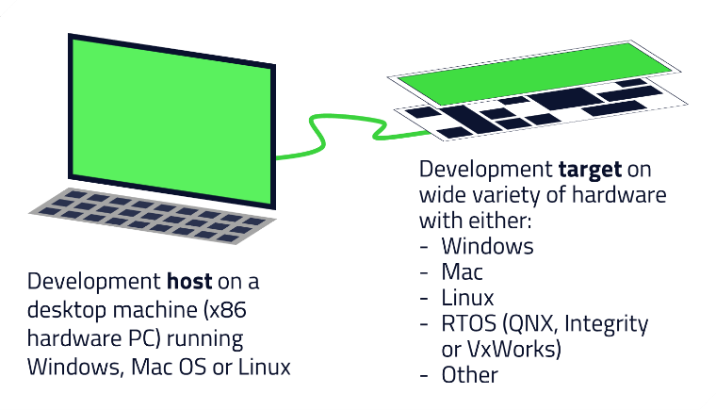
As with any Qt project, the same application can be deployed natively to desktop and mobile OS targets as well.
Qt for Device Creation comes pre-built support for several reference devices. If you need something exotic it can be created with the provided tooling.
Testing on correct target hardware as early in the project as possible is super important in order to
- Find hardware perks and bottle necks early in the project
- Make sure your software architecture suites the target hardware
- Verify that the planned user interface, contrasts, brightness etc. meets your demands
- See what was good user experience plan on design plans is actually also good on target hw

What do you get with Qt for Device Creation?
Integrated Development Environment (IDE) & Tools | Libraries and API’s
Qt Creator comes with a wide range of tools, so you can design your UI, write your code and much more in one cross-platform IDE. Feel like prototyping? Just press play. | Develop faster and smarter with Qt’s Intuitive and comprehensive libraries. Never worry about dependencies: We are updating and future-proofing constantly!

Development environment
Full embedded tooling | - Qt Creator IDE  - UI Design tools for both 2D and 3D  - Direct device deployment  - On-device debugging and profiling  - Internationalization and localization  - Qt Quick Compiler  - Emulator  - Installer/Updater
GUI libraries | - Qt Quick Controls  - Qt 3D  - Qt Widgets
Non-GUI libraries | - Core internals  - Data storage  - Multimedia  - Networking & Connectivity  - Location & Positioning  - Sensors  - + Many more
Value-add solutions | - Virtual keyboard  - Charts  - 3D Data Visualization
Wide cross platform support | Pre-built software stacks for wide variety of hardware  - Yocto Project Recipes  - Tooling to build your own custom stack  Embedded operating systems  - Embedded Linux  - QNX  - INTEGRITY  - VxWorks  - Windows 10 IoT Core  - +other  Desktop operating systems  - Windows  - Linux  - MacOS  Mobile  - Android  - iOS
Professional services and support | - Customized professional services  - Professional support  - Training

Getting Started With Development
Play around with the demos in this launcher to see the power of Qt. Get your free evaluation version of Qt for Device Creation with the Boot to Qt images for common developer boards from
www.qt.io
With an online installer, you will get the out-of-the-box pre-configured development environment, Qt Creator IDE, and you can start your embedded development immediately!

